November 9, 2019
Save the Date!
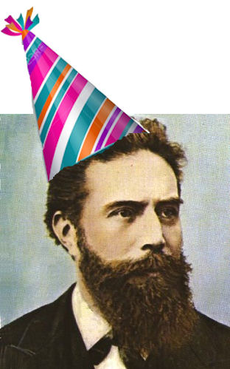
For National Radiologic Technologist Week, the VSRT will be offering
4 free CE credits for members!
We will set up locations around Virginia where technologists can view the lectures and network!
Sites include Lynchburg, Richmond, Roanoke, Springfield, Va Beach, and more!
More information coming soon! Visit us on Facebook, Instagram, and Twitter!
Contact goforwardvsrt@gmail.com for questions or
to become a lecture site

